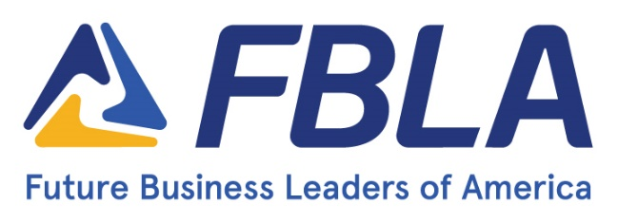
FOR IMMEDIATE RELEASE

Contact: Your Name Here
Contact Information Here
State Website Here

FBLA Business Battle

(October 1 – 31, 2022) – High school and middle school students in Future Business Leaders of America interested in business and leadership competed in the 2022 Business Battle. The online testing tournament allowed members to explore the ranges of competitive events that FBLA offers to members. In nine different tests, members had a wide variety to discover which topics peaked their interest from accounting to computer science to marketing and more.

Over 1300 members from seven states (Colorado, Iowa, Missouri, North Dakota, South Dakota, Virginia, and West Virginia) competed head to head in the battle. (Insert State Wins & State Comments) Members are now prepared to take their competitive events to the next level at the District and State Leadership Conference.

For more information on STATE FBLA, visit state website.

About Future Business Leaders of America
Future Business Leaders of America (FBLA) is a student-led organization whose mission is inspiring and preparing students to become community-minded business leaders in a global society through relevant career preparation and leadership experiences. There are over 230,000 active members in over 5,250 chapters.

###

