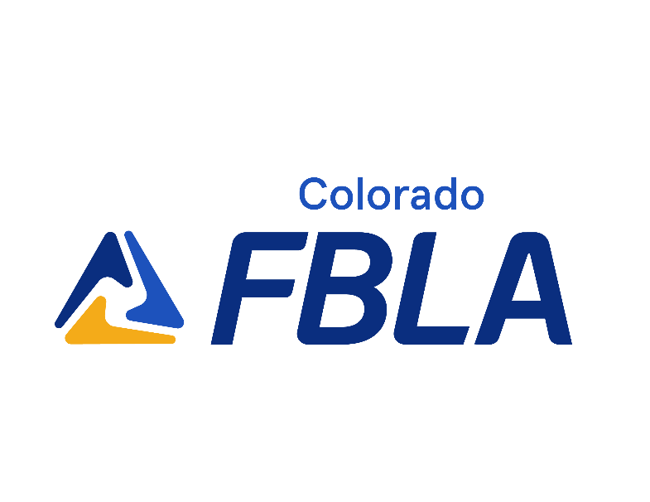

Judge Volunteer Guide
2022 - 2023

Overview
FBLA is committed to developing and implementing vital and innovative programs. The National Awards Program, also known as competitive events, recognizes and rewards excellence in a broad range of business and career-related areas. FBLA competitive events also prepare students for successful careers in business by providing opportunities to apply classroom concepts in a workforce-simulated competitive environment. Students will acquire and apply the skills needed in demanding and ever-changing workplaces. The National Awards Program is an academic competition program that supports the attainment of academic excellence in work readiness, with a secondary focus on math, science, reading, and writing.

Colorado FBLA students at the 2022 National Leadership Conference

The hallmark of the National Awards Program is receiving a top ten placement at the national level. The program consists of three progressive segments: district competition, state competition, and national competition. Although the program has defined levels of competition, students may enter or exit the program at any level of competition.

FBLA Competitive Events
The National Awards Program is comprised of 75+ competitive events focusing on leadership, business, and other business-related areas.

Event Categories
Below is a description of the different types of competitive events offered through the National Awards Program.
- Objective Tests - An online objective test administered in conjunction with the conference focusing on business knowledge.
- Production Tests - Two parts: a hands-on part focusing on technical skills and an online objective test focusing on technical and business knowledge.
- Presentation Events - The presentation of a project, speech, or interview in front of judges. Competitors may be allowed to use technology, equipment and/or visual aids as part of the presentation. Check specific event guidelines to determine what is allowed.
- Case Study Events - Two rounds: first round is an online objective test administered in conjunction with the conference focusing on business knowledge. The top 15 individuals/teams advance to round two, consisting of an extemporaneous response to a prompt. Judges will interact with competitors in a role play format. Check specific event guidelines to determine if the competitive event only has one round.

Conference Participants
- Conference Staff – Colorado FBLA state office personnel and associated individuals who will coordinate with the volunteers, staff, teachers, and students.
- Judges (Business & Industry Volunteers) – You! Individuals listening to, reviewing, and evaluating presentation events including projects, speeches, or interviews.
- Event Administrators/Timekeepers (Teacher Volunteers) - Individuals working with both judges and students to make sure the event runs smoothly.
- Advisers (Educators) – Teachers and other mentors who prepare students for the academic competitions and support student competitors on-site.
- Member Competitors (Students) - Students will participate in the competitive events during the conference, including live presentations in front of judges.

Competitive Events Resources
Each competitive event follows the above publication but may also have supporting documentation including study guides, rating sheets, past case studies, etc.
2022-23 High School Competitive Events Resource Guides

Prejudged Materials
Some competitive events require student competitors to pre-submit materials to be judged prior to the start of the conference or competition. Some of the types of prejudged materials include:
- Cover Letter and Resume
- Projects - Videos, Applications, Games, Websites, etc.
- Reports - Written Reports, Presentations, Visual Aids, etc.
- Production Materials

Judging at the Event
The conference staff is responsible for coordinating judges and ensuring that judges have what they need to make the day a success for student competitors. Judges are asked to support the event for the entirety of the competition through all competitors and provide feedback through the evaluation, scoring, and debriefing process. Additionally, judges are asked to provide a device for online judging, like a laptop computer or tablet. Mobile devices aren’t recommended due to the user experience with judging on a small device.

Judge Orientation
A 30-minute meeting prior to the start of the competitions will provide training and important information related to the judging experience. The orientation meeting is for both first time judges and returning judges to attend, and it will allow judges to ask questions relating to the competition, scoring and evaluation, or any other general questions about judging.

List of Materials Received
When arriving at the conference site, you’ll receive the following materials to support judging during the Judge Orientation meeting.
- Assigned Competitive Event
- Schedule of Competitors
- General Competitive Event Guidelines
- Event Specific Guidelines
- Case Study Information (if applicable)
- FBLA’s Dress Code
- Rating Sheet (online access)

Evaluation and Scoring
Student competitors are evaluated and scored using FBLA’s official rating sheet for the competitive event. Judges are asked to score based solely on the metrics provided on the rating sheet. To create a fair and equal experience for all competitors, judges are asked to not confer with other judges between competitors except for assessing penalty points and tiebreaking.

At the conclusion of judging a competitor, the judges should discuss if any competitors should be assessed penalty points. When assessing penalty points, it is required that all judges assess the same points for the same violation; if one judge disagrees with the penalty, a penalty may not be assessed.

Once all judging has been completed, judges are asked to review and confirm the top ten individuals/team entries in the event. In the event there is a tie for a placement in the top ten, the judges are asked to confer and determine how to rank the competitors. There should be no ties before submitting final scores. Once determined, scores can be adjusted on the rating sheet to reflect the decision made. All judges’ decisions are final in the scoring process.

Comments
Following the conclusion of presentations, the judges are asked to add comments for student and teacher feedback. Judges will share information on what they were looking for in project quality, presentation skills, critical thinking and problem solving, and any other event highlights.
Sample feedback to share and discuss include:
- Professional attitude (example: voice level, shaking hands, introductions)
- Presentation skills (example: speed of presentation or knowledge of PowerPoint)
- Handling issues or unexpected situations during the presentation (example: technical issues or forgetting parts of the presentation)
- Overall technical skills relating to the competition (example: formatting of the financial statements, video quality)
- Student Q&A sessions, if applicable (example: be prepared with answers to commonly asked questions)
- Professional attire (example: provide positive feedback on dress)
- Rating Sheet Knowledge (example: demonstrating knowledge of rating sheet and following all expectations)
- Timing (example: using an appropriate amount of time and not too short or long)
- Visual Aids (example: the proper use of visuals including colors, size, design, etc.

