Colorado FBLA Adviser Pre-Judge Approval Instructions
These instructions apply to only pre-judge competitions:
3-D Animation * Business Ethics * Business Financial Plan * Business Plan
Digital Video Production * Future Business Leader * Job Interview

When logging in, other competitions may be seen. No action needs to be taken for competitions without pre-judge items.

- Visit http://judgespro.registermychapter.com/org/jpco-ds11/conf/jpco-d11
- Type your “User Name” (Chapter ID/User Name that is used to log into the Conference Registration site – most often your “old” chapter ID number)
- Type the appropriate Password in the “Password” field (Note: the password is service)
- Click on the “Login” button.

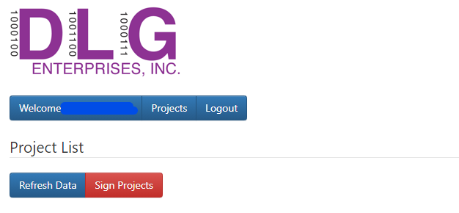

- To view uploaded projects, click on the links located under “Projects”
- Once the projects have been reviewed, the “Statement of Assurance” must be submitted.
- To sign/submit the “Statement of Assurance”, click on the “Sign Projects” button.
- If you agree with the text in the statement, select the “I Agree” checkbox and click on the “Confirm” button by the deadline listed in the Call to Conference.

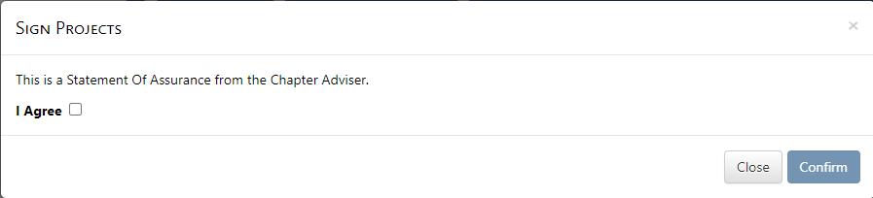

Important: All projects that have a file and/or video URL will be signed and submitted for scoring. Once the projects are “signed”, the student project cannot be edited. Contact Jen Staley (jen.staley@cccs.edu) to have the student project released.

